August 26, 2019 – 4D STEM session for sample MV_1.5_9 (1.2° TBLG)

Summary:

**Probe Size Measurements**

The first half of this session was spent determining the probe size under various conditions at 60 kV. The goal was to begin generating a table of probe sizes (FWHM and 80% of probe) based on convergence angle, aperture size, spot size, etc. The probe images can be found under the folder “Probe images 60 kV”. At 1 mrad convergence angle for spot 9 and a 40 um aperture, a minimum probe size of 1.6 nm (FWHM)/2.8 nm (80%) was achieved. Under these same conditions but using a 1.5 mrad convergence angle, the minimum probe size was 1.15 nm (FWHM)/ 2 nm (80%).

**Diffraction Measurements**

Since the moiré unit cell size for 1.2° is 11.7 nm, we started with the 1 mrad convergence (~1.6-1.8 nm FWHM, 2.8-3.1 nm at 80%). The uncertainty in probe size comes from the fact that at these larger convergence angles, even a small (50-100 nm) shift out of focus can significantly change the probe size. The thought was that if we can resolve these disks, then we could try with even larger Bragg disks (smaller probe) next time if we need better real space resolution.

We collected three sets of data. The first (file 1) was a test to see how long data collection would take when binning by 1. File 2 is probably the most useful file collected. We used the same conditions as in File 1, but increased the exposure time to improve signal:noise and increased the scan area. File 3 would have been the best data set since we increased the exposure time again and decreased the spot size (higher electron flux), *but* we realized that the probe was elliptical after collection. The resulted from changing the spot size and not having time to recheck the beam stigmation. For now, we can work with File 2, which had a circular beam. During the next session we can try again with a higher electron flux and long exposure.

**Collection Parameters for File 2:**

Acc. Voltage: 60 kV

Condenser Aperture: 40 um

Convergence Angle: 1 mrad

Spot Size: 9

Exposure Time: 1 s

Binning: 1

Probe Size: 1.6 – 1.8 nm (FWHM), 2.8 – 3.1 nm (80%)

Step Size: 3 nm

Moiré Unit Cell Size: 11.7 nm

Field of View: Two full rings included in pattern, with beam stop

**Observations:**

Due to the significant overlap in the graphene disks, interference patterns are observed in the overlap regions. Small, uniform crescent moons may be visible in the areas where there is no overlap (particularly in the outer ring). These could allow for individual disk detection; however, it may be to our advantage to see what information comes from these regions with interference. The patterns are not uniform around the rings, and there is an apparent shift from pattern to pattern – maybe because of strain(?).

**Follow-up – here are some routes to consider based on what we find with this set of data:**

1. If we need better real space resolution, we can decrease the probe size by:
   1. Increasing the convergence angle – this will increase the size of the Bragg disks but electron flux doesn’t change
   2. Increasing the spot size – this changes probe size less rapidly, but it also decreases electron flux
2. If we need better signal to noise, we can decrease the spot size and continue increasing exposure time. However, decreasing the spot size does increase probe size, so again we may have to adjust convergence angle.

**NK follow-up: Thanks; this is exciting! Here are some questions and initial observations that I have.**

1. **Can you give a rough estimate of how long it takes to collect each dataset? For instance, the dataset labeled 2 is 20x20 with a 1 second exposure time, so is the total collection time 400 seconds ~= 7 min? Or is there some limiting factor to the experiment besides exposure? I’m curious to get a feel for where the time required in 4DSTEM typically comes from.**

**You are correct – the exposure time determines how long data collection will take. I believe we used longer exposure times because we only binned by 1. So a 20 x 20 scan with 1 s exposure does take about 7 min. And also the first hour or so is spent just setting up the sample in the TEM, doing beam alignments, etc.**

1. **Can you give a brief explanation of spot size? How is that different than probe size?**

**I think the distinction between spot size and probe size can get a bit blurry. But spot size just refers to the size of the beam that can focus on the sample for a given strength of the first condenser lens. A larger spot size results in a smaller, weaker beam. There is a button on the TEM that you press to switch spot size. The final probe size is influenced by the spot size, but you can further adjust it with the convergence angle. So I guess spot size dictates a possible range for the probe size as well as how intense the probe will be on the sample.**

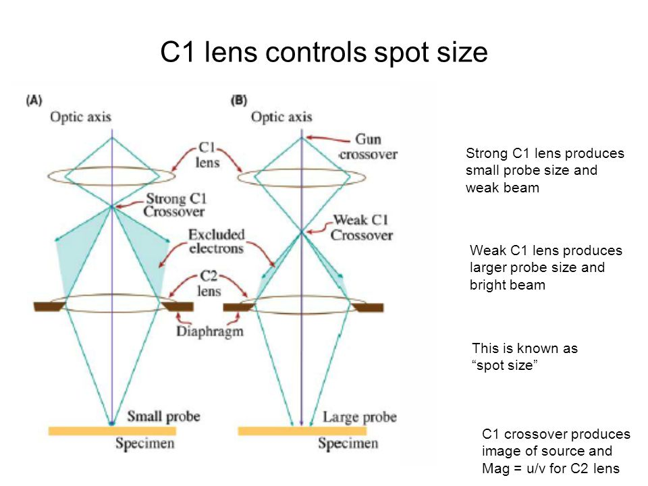

1. **With regard to the interference patterns: if you scan across real space pixels in py4DSTEM, you can watch the interference patterns move in an apparently continuous fashion. For both datasets, scanning across real space pixels in one direction yields a “fast” movement of the interference pattern, while scanning across real space in the other direction yields a “slow” movement of the interference pattern. I’ll try to quantify the movement of the patterns.**

**I’m interested, though, in why it seems like the “fast” and “slow” dimensions are switched for dataset 2 and dataset 3. For dataset 2, the Rx direction is “fast”, while for dataset 3, the Rx direction is “slow”? Any thoughts on why this might be? Does the sample remain in the microscope in the period between the collection of the two datasets, and do you know if the microscope Rx and Ry directions for dataset 2 correspond to those of dataset 3?**

**I have no idea, but that is strange. Nothing was changed during the two scans. The sample definitely remained in the microscope. I can ask Karen if somehow the scan direction could have switched, but I doubt it.**

1. **Our original disk registration ideas are probably not going to be of much use here, since I struggle to even visually make out the different disks. We might have to see if we can extract anything useful from the interference pattern, which I’ll start looking into.**

**Follow-up task: we (or at least I) need to improve our understanding of the origin of inner structure on the disks, seeing as we now need to deal with them. In particular, what is the difference between the coherent and incoherent summation that Colin was mentioning, and how would we be able to theoretically predict the difference?**

**I’ll start looking into this as well. I’m not familiar with where the structure in the disks comes from.**